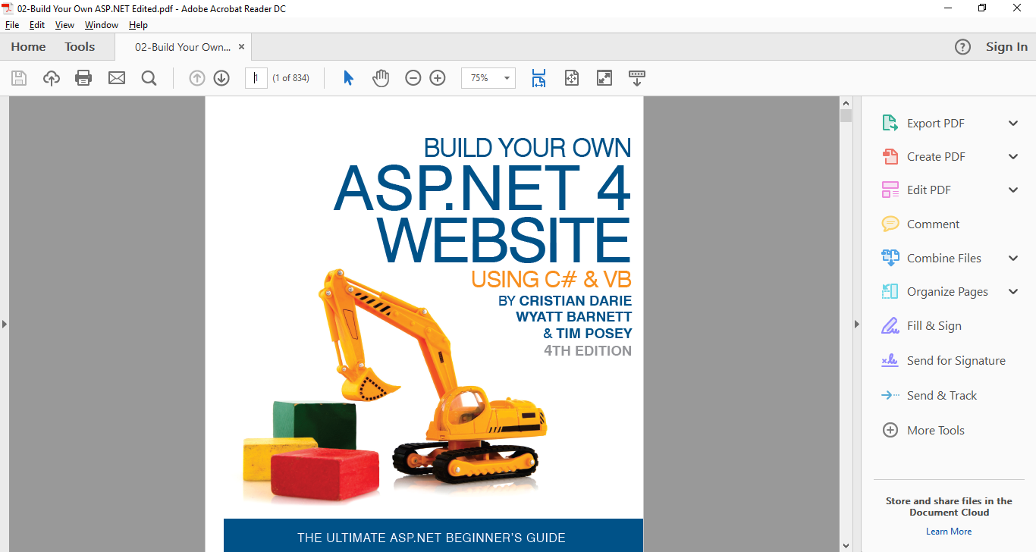

Assignment #02:

COURSE COMP229 Winter 2017

**CENTENNIAL COLLEGE**

Fabio Alexandre Ciconi | 300930989 | 17/02/2017

Contents

Calendar 2

AdRotator 3

SiteMapPath 5

Menu \ TreeView 6

MultiView 8

Wizard 10

FileUpload 13

ImageMap 15

Place Holder 16

Panel 17

HTML /ASP 18

C# 25

Pages 28

CSS 30

XML 34

## Calendar

//When user choose Monday change the weekeend color

//Warning when the user try to choose a day before actual day

protected void CalendarFabio_SelectionChanged(object sender, EventArgs e)

{

LabelDate.Text = "You choose the date:..." + CalendarFabio.SelectedDate.ToShortDateString();

if (CalendarFabio.SelectedDate.Date < DateTime.Today)

{

LabelDate.Text = "NO Man...Choose a day in the future:...";

}

else if (CalendarFabio.SelectedDate.DayOfWeek == DayOfWeek.Monday)

{

CalendarFabio.WeekendDayStyle.BackColor = System.Drawing.ColorTranslator.FromHtml("#F2F0E1");

LabelDate.Text = "Monday the color changed:..." + CalendarFabio.SelectedDate.ToShortDateString();

}

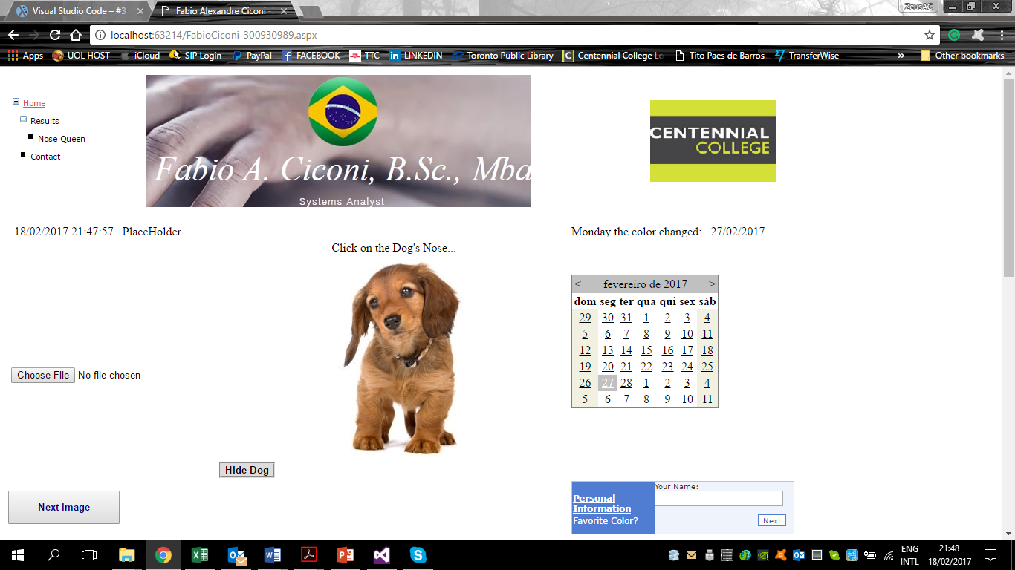

## AdRotator

<?xml version="1.0" encoding="utf-8" ?>

<Advertisements>

<Ad>

<ImageUrl>\Images-fabio\CentennialCollege-banner.jpg</ImageUrl>

<NavigateUrl>http://www.centennialcollege.ca/</NavigateUrl>

<TargetUrl>_blank</TargetUrl>

<AlternateText>blank</AlternateText>

<Keyword>blank</Keyword>

<Impressions>1</Impressions>

</Ad>

<Ad>

<ImageUrl>\Images-fabio\Banner-Fabio.jpg</ImageUrl>

<NavigateUrl>http://www.fabiociconi.wixsite.com/meusite</NavigateUrl>

<TargetUrl>_blank</TargetUrl>

<AlternateText>blank</AlternateText>

<Keyword>blank</Keyword>

<Impressions>2</Impressions>

</Ad>

<Ad>

<ImageUrl>\Images-fabio\banner-teacher.png</ImageUrl>

<NavigateUrl>http://smrdibaj.wixsite.com/smrezadibaj/teaching</NavigateUrl>

<TargetUrl>_blank</TargetUrl>

<AlternateText>blank</AlternateText>

<Keyword>blank</Keyword>

<Impressions>3</Impressions>

</Ad>

</Advertisements>

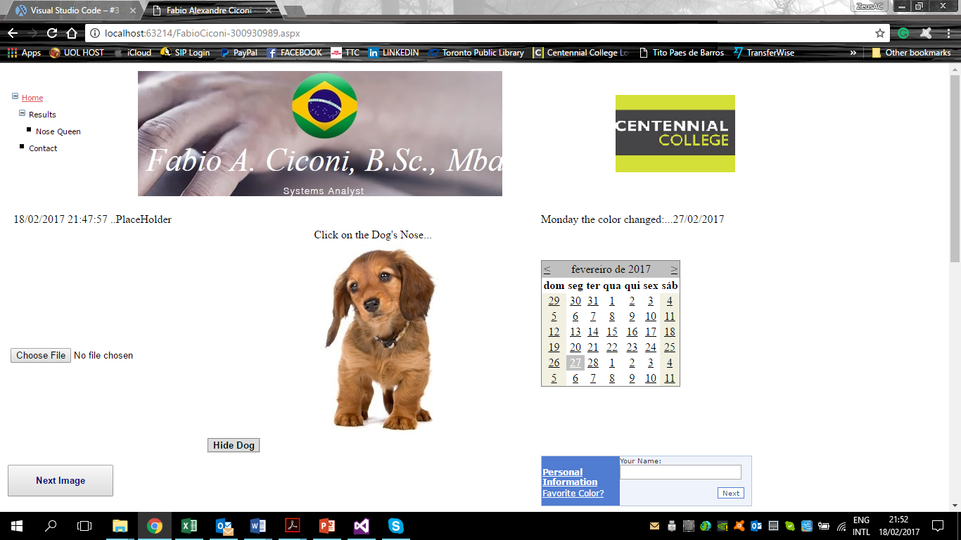

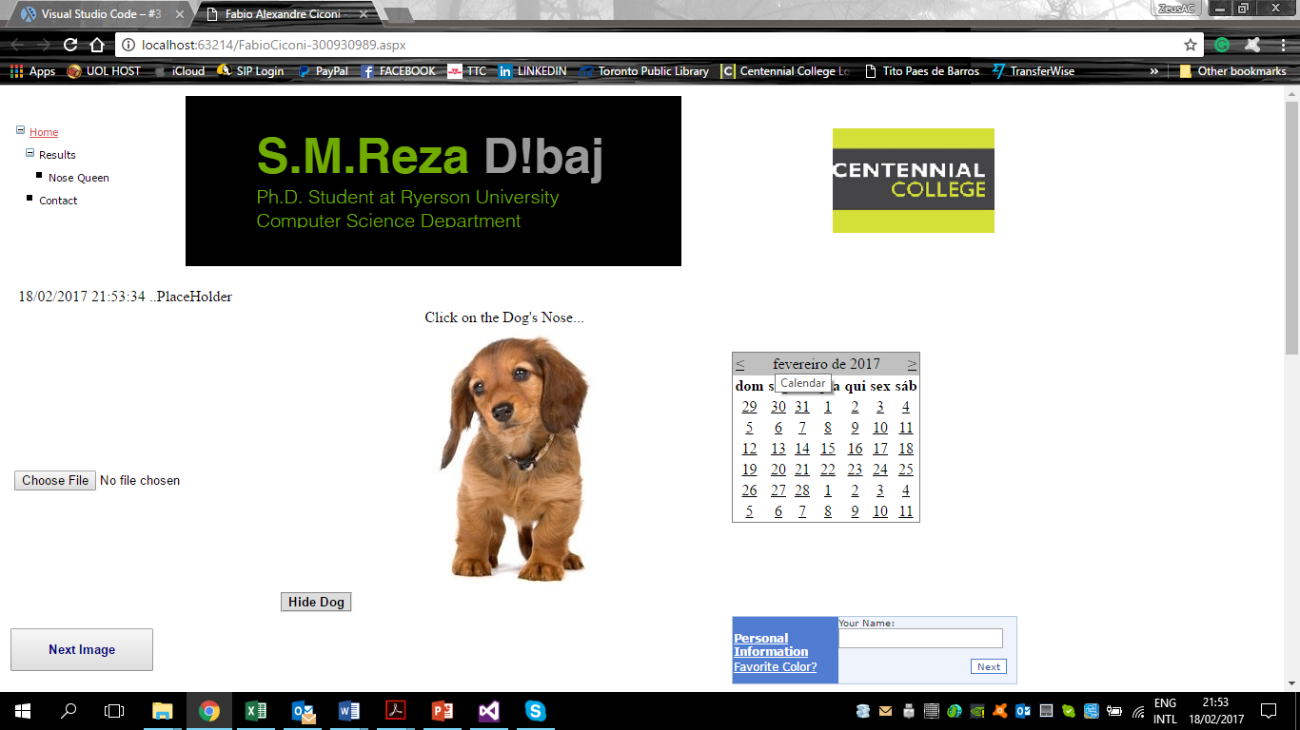

## SiteMapPath

<?xml version="1.0" encoding="utf-8" ?>

<siteMap xmlns="http://schemas.microsoft.com/AspNet/SiteMap-File-1.0" >

<siteMapNode url="~/FabioCiconi-300930989.aspx" title="Home" description="Home Page">

<siteMapNode url="" title="Results" description="Results of Clicks" >

<siteMapNode url="~/QueenNose.aspx" title="Nose Queen" description="Queen" />

</siteMapNode>

<siteMapNode url="Contact.aspx" title="Contact" description="ContacUs Page" />

</siteMapNode>

</siteMap>

<!-- Site Map-->

<asp:SiteMapDataSource ID="SiteMapDataSource1" runat="server" />

<asp:SiteMapPath ID="mySiteMapPath" runat="server"

PathSeparator=" : " SkipLinkText="" Font-Names="Verdana" Font-Size="0.8em">

<CurrentNodeStyle ForeColor="#333333" />

<NodeStyle Font-Bold="True" ForeColor="#284E98" />

<PathSeparatorStyle Font-Bold="True" ForeColor="#507CD1" />

<RootNodeStyle Font-Bold="True" ForeColor="#507CD1" />

</asp:SiteMapPath>

<br />

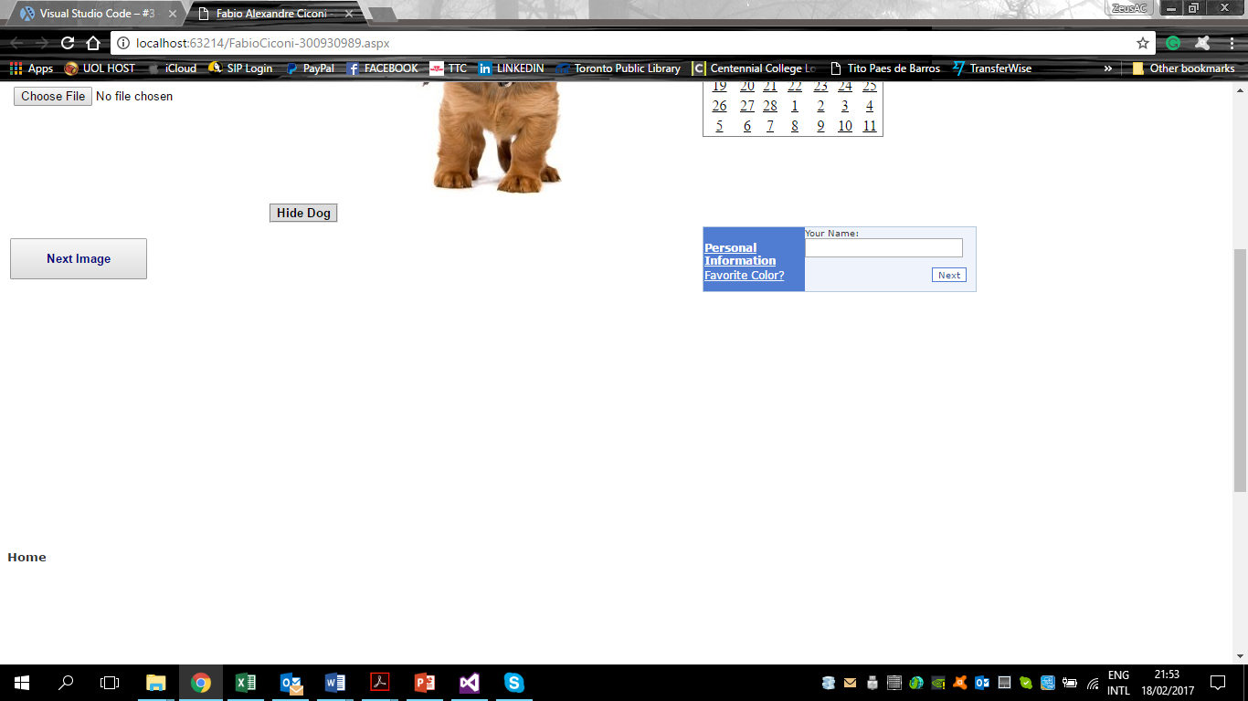

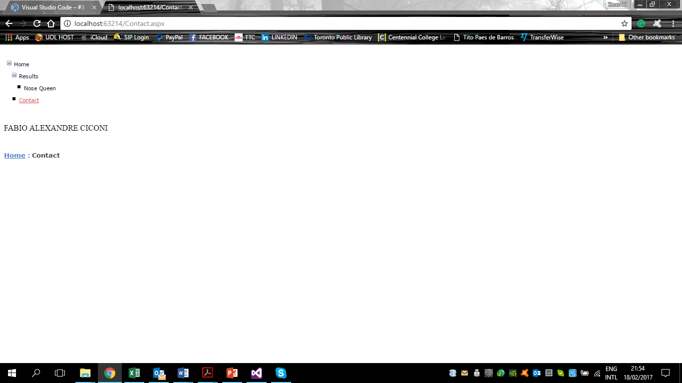

## Menu \ TreeView

<!-- Show Menu -->

<asp:TreeView ID="myMenu" runat="server" DataSourceID="mySiteMapDataSource" ImageSet="Simple" NodeIndent="10">

<HoverNodeStyle Font-Underline="True" ForeColor="#DD5555" />

<NodeStyle Font-Names="Verdana" Font-Size="8pt" ForeColor="Black" HorizontalPadding="0px" NodeSpacing="0px" VerticalPadding="0px" />

<ParentNodeStyle Font-Bold="False" />

<SelectedNodeStyle Font-Underline="True" ForeColor="#DD5555" HorizontalPadding="0px" VerticalPadding="0px" />

</asp:TreeView>

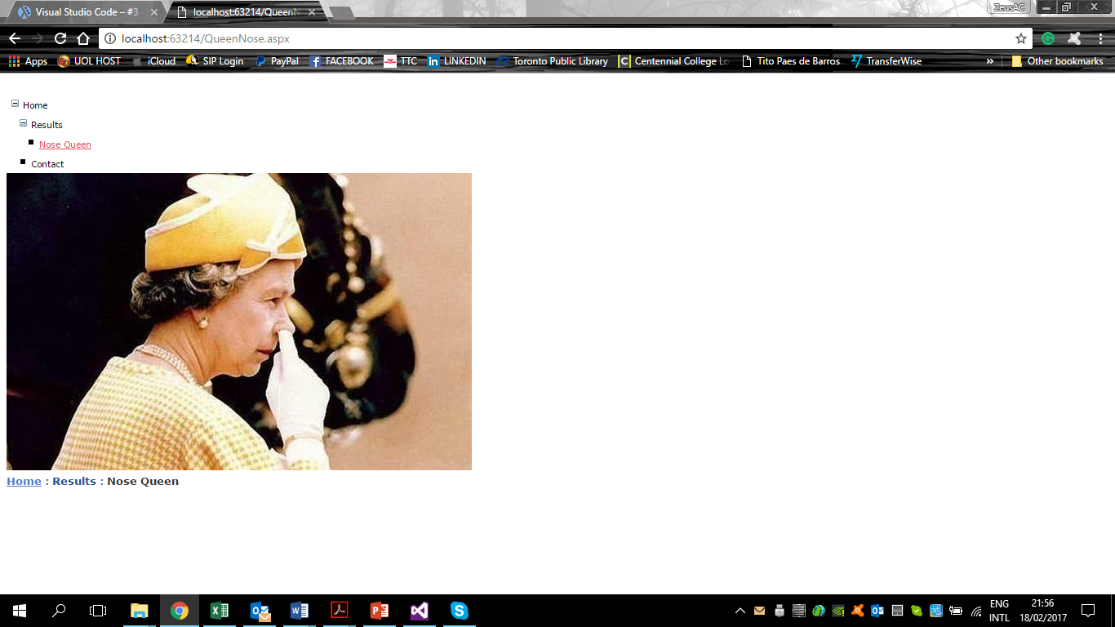

## MultiView

<table>

<!-- Multiview Images - Change when the user clik on the next button-->

<asp:MultiView ID="MultiView1" runat="server">

<asp:View ID="View1" runat="server">

<asp:Image ID="Image_view1" runat="server" Height="250px" ImageUrl="~/Images-fabio/image_view1.jpg" />

</asp:View>

<asp:View ID="View2" runat="server">

<asp:Image ID="Image2" runat="server" Height="250px" ImageUrl="~/Images-fabio/image_view2.jpg" /></asp:View></asp:MultiView></table>

//CONTROL MULTIVIEW

protected void NextImage(object sender, System.EventArgs e)

{

if (MultiView1.ActiveViewIndex < 1)

{

MultiView1.ActiveViewIndex += 1;

}

else

{

MultiView1.ActiveViewIndex = 0;

}

}

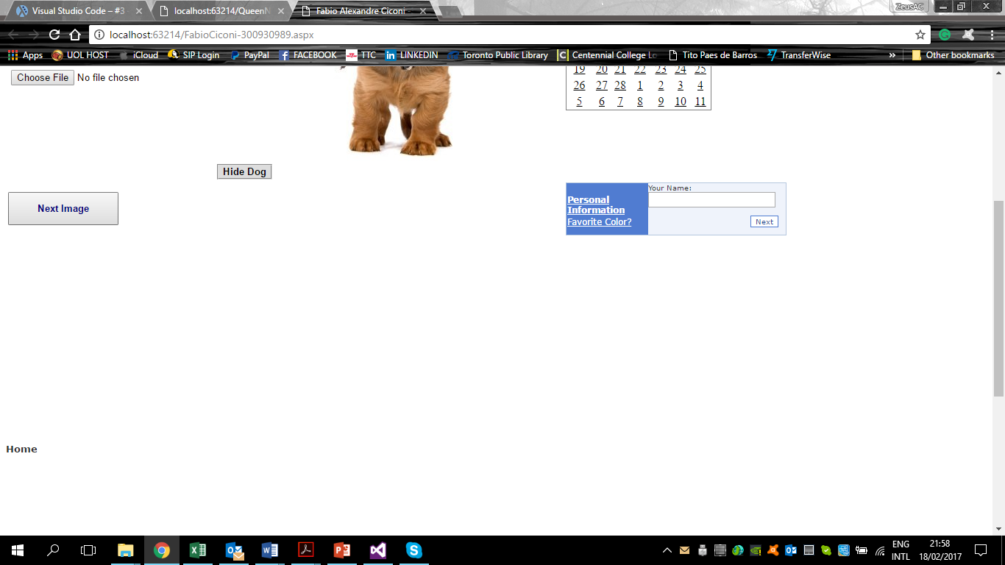

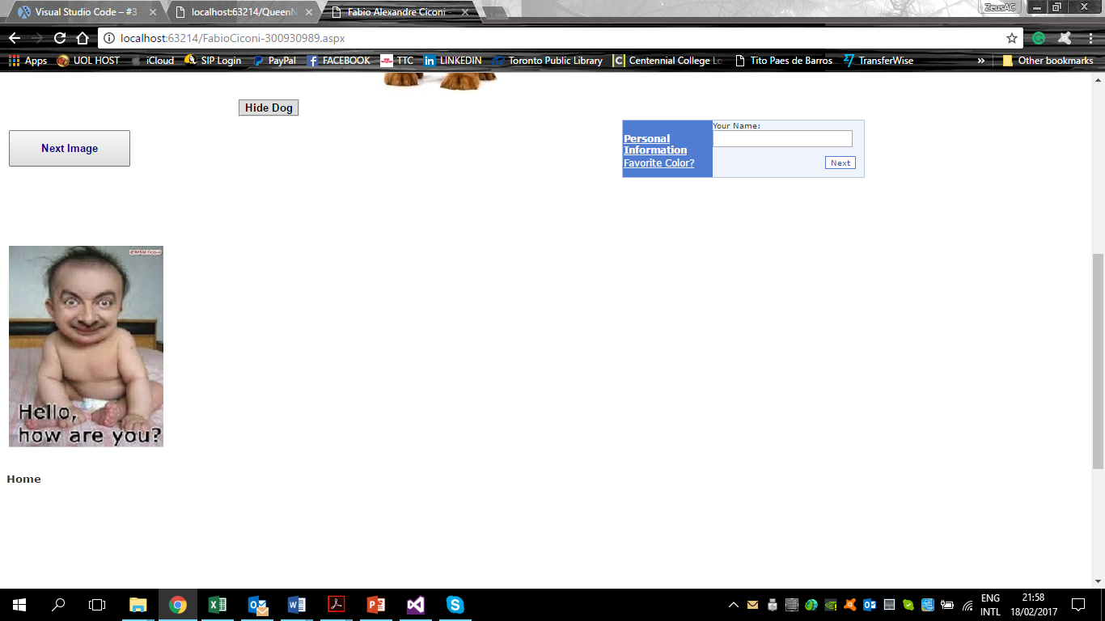

## Wizard

//Show the result of wizard

protected void Wizard1_FinishButtonClick(object sender, WizardNavigationEventArgs e)

{

LabelResult.Visible = true;

LabelResult.Text = "Your Name is : " + TextName.Text +

"<br/> Your favorite color is : " + RadioButtonList1.SelectedItem.Text.ToString();

}

<!-- Form Wizard to put name and choose the color-->

<asp:Wizard ID="Wizard1" runat="server" BackColor="#EFF3FB" BorderColor="#B5C7DE" BorderWidth="1px" Font-Names="Verdana" Font-Size="0.8em" Width="300px" ActiveStepIndex="0" OnFinishButtonClick="Wizard1_FinishButtonClick">

<HeaderStyle BackColor="#284E98" BorderColor="#EFF3FB" BorderStyle="Solid" BorderWidth="2px" Font-Bold="True" Font-Size="0.9em" ForeColor="White" HorizontalAlign="Center" />

<NavigationButtonStyle BackColor="White" BorderColor="#507CD1" BorderStyle="Solid" BorderWidth="1px" Font-Names="Verdana" Font-Size="0.8em" ForeColor="#284E98" />

<SideBarButtonStyle BackColor="#507CD1" Font-Names="Verdana" ForeColor="White" />

<SideBarStyle BackColor="#507CD1" Font-Size="0.9em" VerticalAlign="Top" />

<StepStyle Font-Size="0.8em" ForeColor="#333333" />

<WizardSteps>

<asp:WizardStep ID="WizardStep1" runat="server" Title="Personal Information">

<asp:Label ID="LabelName" runat="server" Text="Your Name:"></asp:Label><asp:TextBox ID="TextName" runat="server"></asp:TextBox>

</asp:WizardStep>

<asp:WizardStep ID="WizardStep2" runat="server" Title="Favorite Color?">

<asp:Label ID="LabelColor" runat="server" Text="Your Favorite Color:" AssociatedControlID="RadioButtonList1"></asp:Label>

<asp:RadioButtonList ID="RadioButtonList1" runat="server">

<asp:ListItem>Green</asp:ListItem>

<asp:ListItem>Blue</asp:ListItem>

</asp:RadioButtonList>

</asp:WizardStep>

</WizardSteps></asp:Wizard>

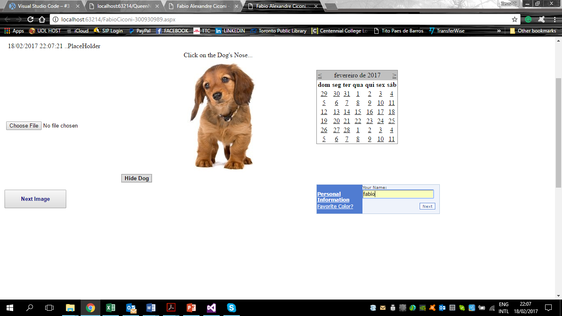

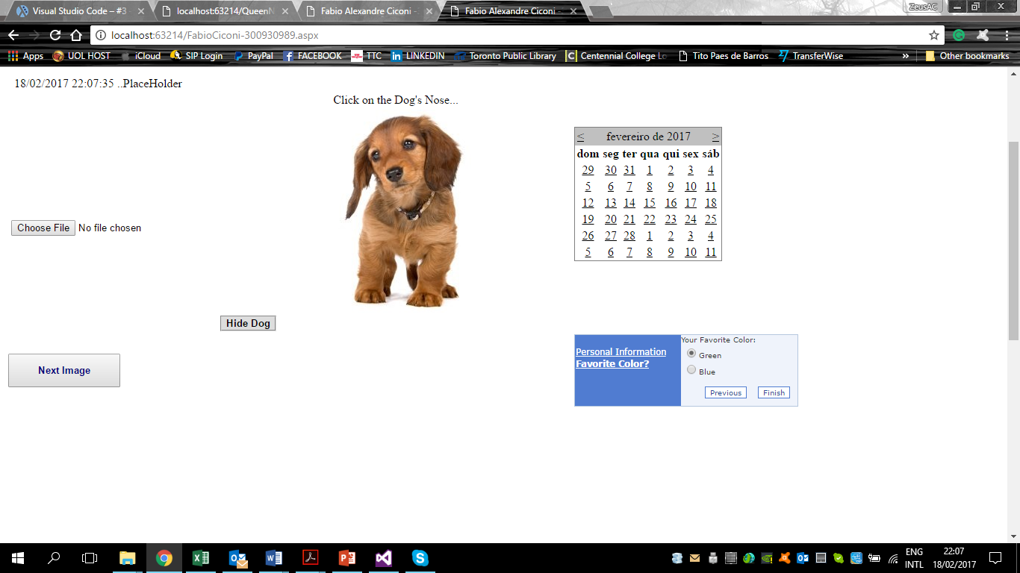

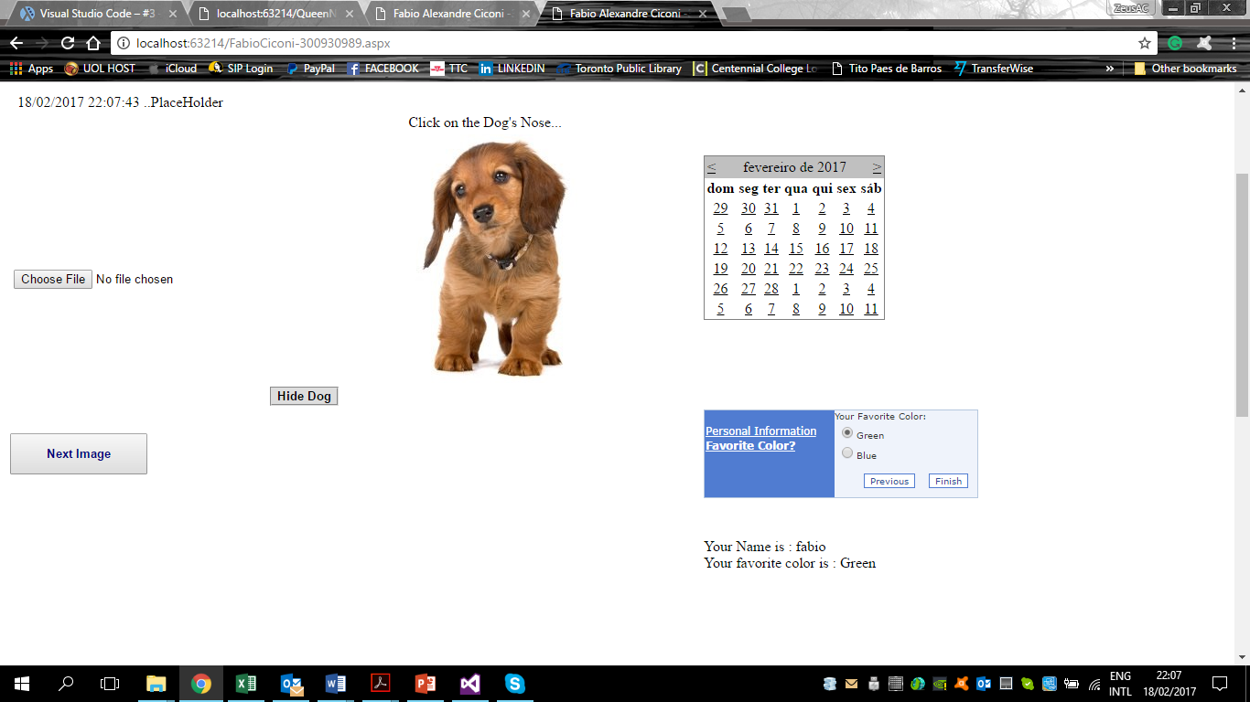

## FileUpload

//files upload

protected void UploadButton_Click(object sender, EventArgs e)

{

string folderPath = Server.MapPath("~/Files/");

if (FileUploadFabio.HasFile)

{

try

{

FileUploadFabio.SaveAs(folderPath + Path.GetFileName(FileUploadFabio.FileName));

StatusLabel.Text = "Upload status: File uploaded!";

}

catch (Exception ex)

{

StatusLabel.Text = "Upload status: The file could not be uploaded. The following error occured: " + ex.Message;

}

}

}

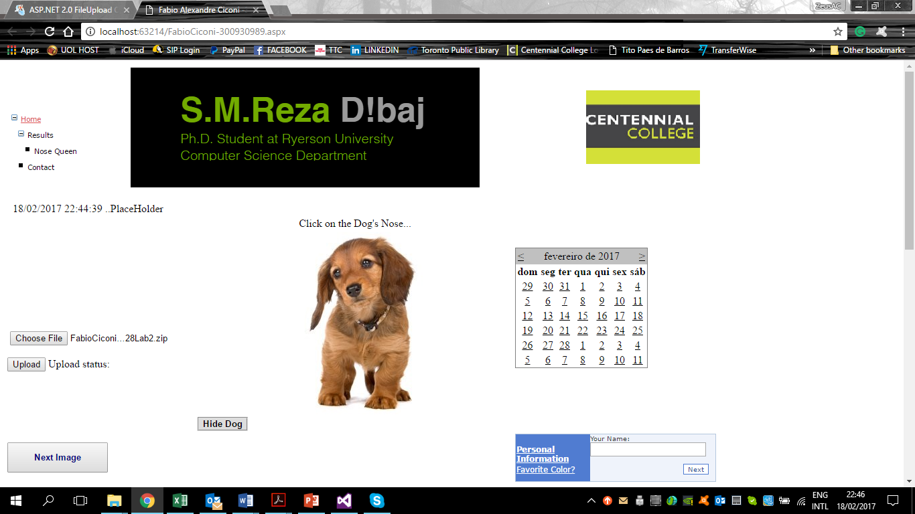

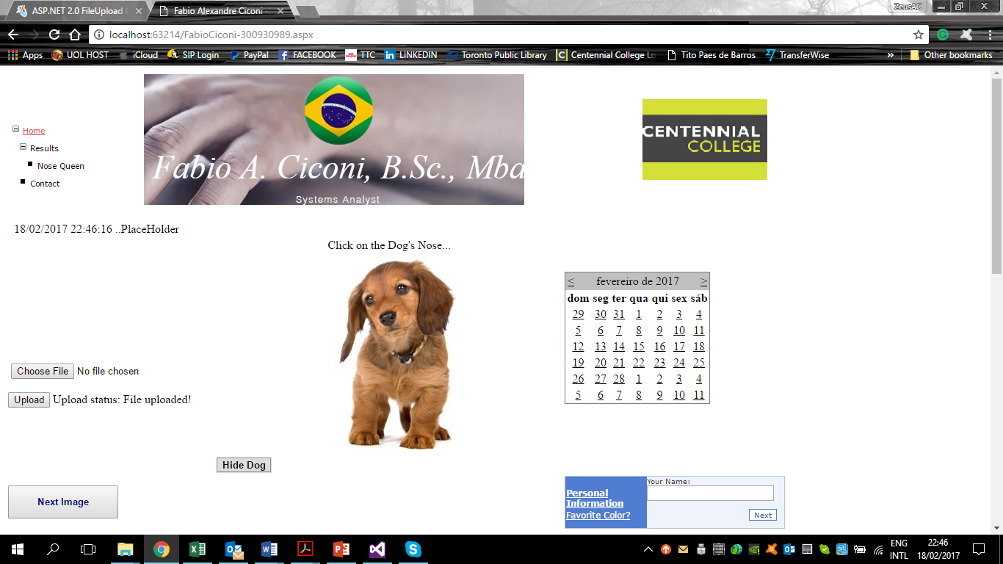

## ImageMap

<asp:Panel ID="PanelFabioDog" runat="server">

<!-- Dog's image -->

<asp:ImageMap ID="myImagMap" ImageUrl="Images-fabio/cao.jpg" HotSpotMode="Navigate" runat="server" BorderStyle="None" ImageAlign="AbsBottom">

<asp:CircleHotSpot Radius="8" X="231" Y="87" NavigateUrl="~/Fabio-Page2.aspx" />

</asp:ImageMap></asp:Panel>

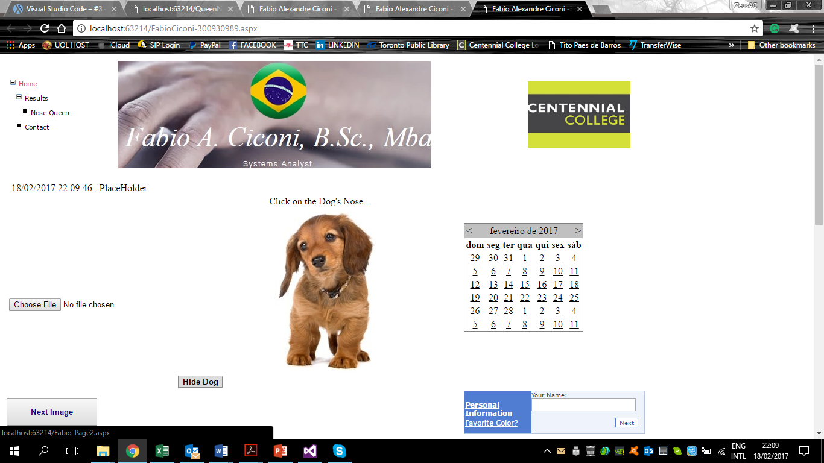

## Place Holder

//show date using Placeholder

protected void Page_Load(object sender, EventArgs e)

{

Label myLabel = new Label();

myLabel.Text = Convert.ToString(DateTime.Now +" ..PlaceHolder");

PlaceHolderFabio.Controls.Add(myLabel);

}

<td class="auto-style34" rowspan="3">&nbsp;

<!-- PalceHolder that shows Date -->

<asp:PlaceHolder ID="PlaceHolderFabio" runat="server"></asp:PlaceHolder>

</td>

<!-- Show Now Date -->

<asp:Label ID="LabelDate" runat="server"></asp:Label>

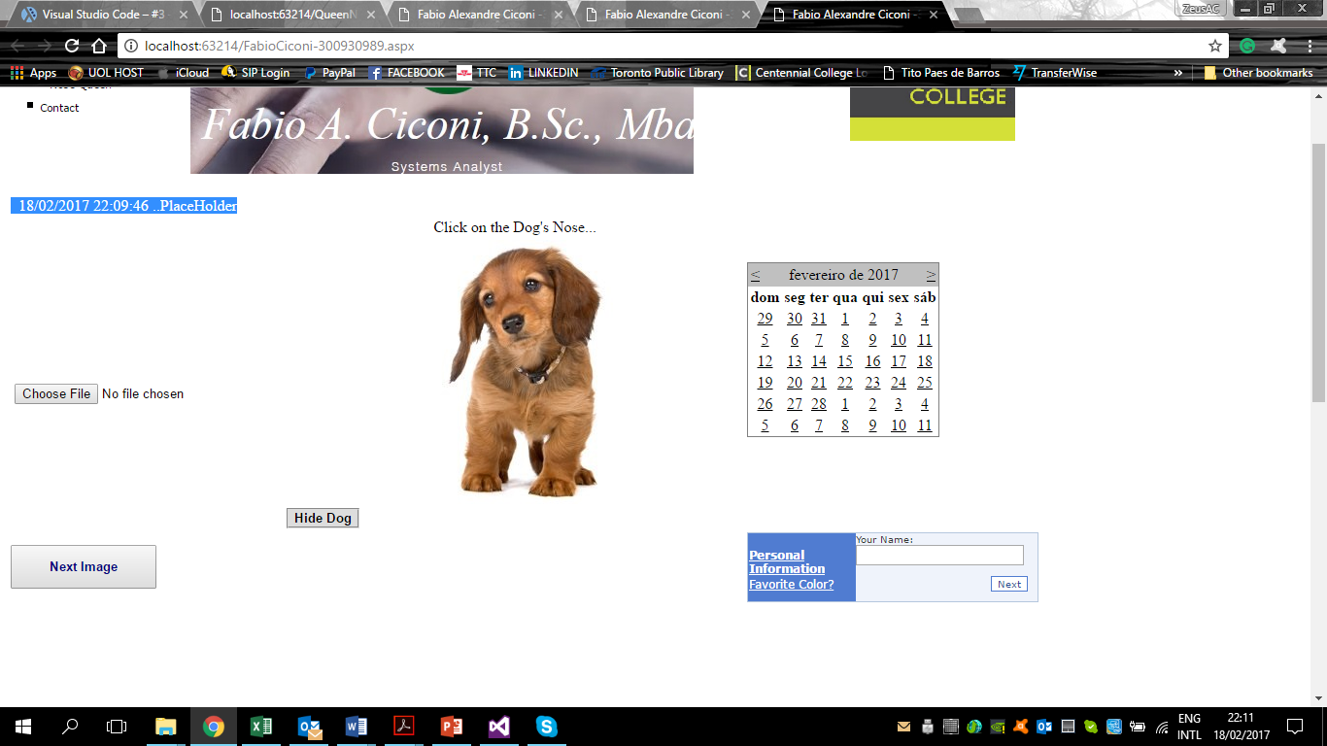

## **Panel**

asp:Panel ID="PanelFabioDog" runat="server">

<!-- Dog's image -->

<asp:ImageMap ID="myImagMap" ImageUrl="Images-fabio/cao.jpg" HotSpotMode="Navigate" runat="server" BorderStyle="None" ImageAlign="AbsBottom">

<asp:CircleHotSpot Radius="8" X="231" Y="87" NavigateUrl="~/Fabio-Page2.aspx" />

</asp:ImageMap></asp:Panel>

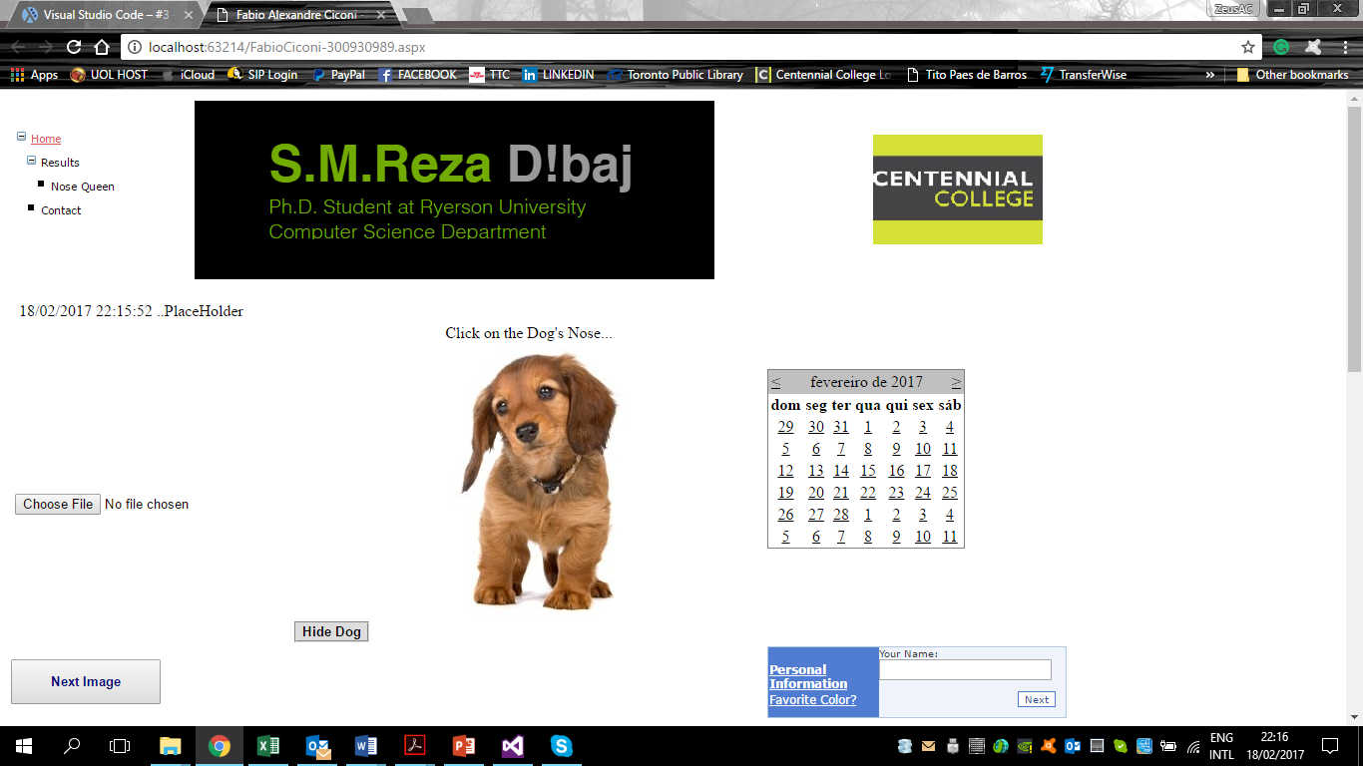

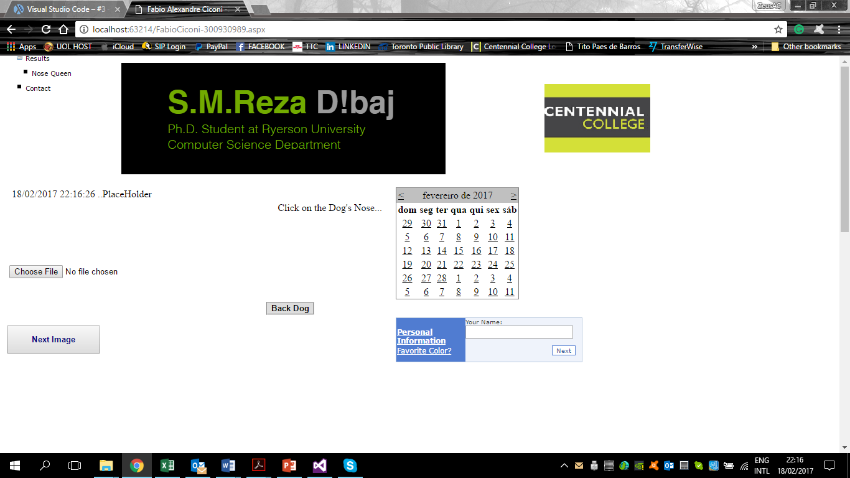

## **HTML /ASP**

<%@ Page Language="C#" AutoEventWireup="true" CodeBehind="FabioCiconi-300930989.aspx.cs" Inherits="Projetct_2__Assignment02.FabioCiconi_300930989" %>

<!DOCTYPE html>

<script runat="server">

//-- Hide the panel when user click in the button

public void HidePanel(Object s, EventArgs e)

{

PanelFabioDog.Visible = false;

ButtonHideDog.Visible = false;

ButtonBackDog.Visible = true;

}

//-- Back with the panel when user click in the button

public void BackPanel(Object s, EventArgs e)

{

PanelFabioDog.Visible = true;

ButtonHideDog.Visible = true;

ButtonBackDog.Visible = false;

}

</script>

<html xmlns="http://www.w3.org/1999/xhtml">

<head runat="server">

<title>Fabio Alexandre Ciconi -300930989</title>

<!-- link with CSS file -->

<style type="text/css"></style>

<link href="StyleSheet-FabioCiconi-3009300989.css" rel="stylesheet" type="text/css" />

</head>

<body style="width: 1115px; height: 1435px;">

<form id="form1" runat="server">

<div class="auto-style27">

<table class="auto-style26">

<tr>

<td class="auto-style28"></td>

<td class="auto-style29">

<!-- Banner -->

<asp:AdRotator ID="AdRotatorFabio" runat="server" DataSourceID="XmlDataSource1" />

<asp:XmlDataSource ID="XmlDataSource1" runat="server" DataFile="~/XMLBanner.xml"></asp:XmlDataSource>

</td>

<td class="auto-style37">&nbsp;</td>

<td class="auto-style37">

<!-- Logo Centennial -->

<asp:Image ID="Image1" runat="server" ImageUrl="~/Images-fabio/logo1.png" />

</td>

</tr>

</table>

</div>

<table class="auto-style48">

<tr>

<td class="auto-style34" rowspan="3">&nbsp;

<!-- PalceHolder that shows Date -->

<asp:PlaceHolder ID="PlaceHolderFabio" runat="server"></asp:PlaceHolder>

</td>

<td class="auto-style39">&nbsp;</td>

<td class="auto-style46" rowspan="3">

<!-- Show Now Date -->

<asp:Label ID="LabelDate" runat="server"></asp:Label>

</td>

<td>&nbsp;</td>

</tr>

<tr>

<td class="auto-style42">&nbsp;</td>

<td>&nbsp;</td>

</tr>

<tr>

<!-- Label to click on Dog's Nose -->

<td class="auto-style44">Click on the Dog&#39;s Nose...</td>

<td>&nbsp;</td>

</tr>

<tr>

<!-- Upload Command -->

<td class="auto-style43" rowspan="2">&nbsp;<asp:FileUpload ID="FileUploadFabio" runat="server" />

<br />

<br />

<asp:Button runat="server" id="UploadButton" text="Upload" onclick="UploadButton_Click" />

<asp:Label runat="server" ID="StatusLabel" Text="Upload status: " />

&nbsp;

<!-- Show Menu -->

<asp:TreeView ID="myMenu" runat="server" DataSourceID="mySiteMapDataSource" ImageSet="Simple" NodeIndent="10">

<HoverNodeStyle Font-Underline="True" ForeColor="#DD5555" />

<NodeStyle Font-Names="Verdana" Font-Size="8pt" ForeColor="Black" HorizontalPadding="0px" NodeSpacing="0px" VerticalPadding="0px" />

<ParentNodeStyle Font-Bold="False" />

<SelectedNodeStyle Font-Underline="True" ForeColor="#DD5555" HorizontalPadding="0px" VerticalPadding="0px" />

</asp:TreeView>

<!-- Map -->

<asp:SiteMapDataSource ID="mySiteMapDataSource" runat="server" />

</td>

<td class="auto-style50">

<!-- Panel that that interact with dog's image -->

<asp:Panel ID="PanelFabioDog" runat="server">

<!-- Dog's image -->

<asp:ImageMap ID="myImagMap" ImageUrl="Images-fabio/cao.jpg" HotSpotMode="Navigate" runat="server" BorderStyle="None" ImageAlign="AbsBottom">

<asp:CircleHotSpot Radius="8" X="231" Y="87" NavigateUrl="~/Fabio-Page2.aspx" />

</asp:ImageMap>

</asp:Panel>

</td>

<td class="auto-style51">&nbsp;<br />

<br />

<br />

<!-- Calendar that change on Mondays-->

<asp:Calendar ID="CalendarFabio" runat="server" OnSelectionChanged="CalendarFabio_SelectionChanged"></asp:Calendar>

</td>

<td class="auto-style52"></td>

</tr>

<tr>

<td class="auto-style54">

<!-- Button to hide dog's image -->

<asp:Button ID="ButtonHideDog" runat="server" BorderStyle="Groove" Font-Bold="True" Font-Overline="False"

Font-Strikeout="False" Font-Underline="False" Text="Hide Dog" OnClick="HidePanel" />

<!-- Button to back dog's image -->

<asp:Button ID="ButtonBackDog" runat="server" BorderStyle="Groove" Font-Bold="True" Font-Overline="False" Visible="false"

Font-Strikeout="False" Font-Underline="False" Text="Back Dog" OnClick="BackPanel" />

</td>

<td class="auto-style55"></td>

<td class="auto-style56"></td>

</tr>

<tr>

<td class="auto-style43">

<!-- Button to change Image Next View -->

<asp:Button ID="ButtonNext" runat="server" Text="Next Image" OnClick="NextImage" Font-Bold="true" ForeColor="Navy" Height="45" Width="150" />

</td>

<td class="auto-style42"></td>

<td class="auto-style47">

<!-- Form Wizard to put name and choose the color-->

<asp:Wizard ID="Wizard1" runat="server" BackColor="#EFF3FB" BorderColor="#B5C7DE" BorderWidth="1px" Font-Names="Verdana" Font-Size="0.8em" Width="300px" ActiveStepIndex="0" OnFinishButtonClick="Wizard1_FinishButtonClick">

<HeaderStyle BackColor="#284E98" BorderColor="#EFF3FB" BorderStyle="Solid" BorderWidth="2px" Font-Bold="True" Font-Size="0.9em" ForeColor="White" HorizontalAlign="Center" />

<NavigationButtonStyle BackColor="White" BorderColor="#507CD1" BorderStyle="Solid" BorderWidth="1px" Font-Names="Verdana" Font-Size="0.8em" ForeColor="#284E98" />

<SideBarButtonStyle BackColor="#507CD1" Font-Names="Verdana" ForeColor="White" />

<SideBarStyle BackColor="#507CD1" Font-Size="0.9em" VerticalAlign="Top" />

<StepStyle Font-Size="0.8em" ForeColor="#333333" />

<WizardSteps>

<asp:WizardStep ID="WizardStep1" runat="server" Title="Personal Information">

<asp:Label ID="LabelName" runat="server" Text="Your Name:"></asp:Label><asp:TextBox ID="TextName" runat="server"></asp:TextBox>

</asp:WizardStep>

<asp:WizardStep ID="WizardStep2" runat="server" Title="Favorite Color?">

<asp:Label ID="LabelColor" runat="server" Text="Your Favorite Color:" AssociatedControlID="RadioButtonList1"></asp:Label>

<asp:RadioButtonList ID="RadioButtonList1" runat="server">

<asp:ListItem>Green</asp:ListItem>

<asp:ListItem>Blue</asp:ListItem>

</asp:RadioButtonList>

</asp:WizardStep>

</WizardSteps>

</asp:Wizard>

</td>

<td>&nbsp;</td>

</tr>

<tr>

<td class="auto-style43" rowspan="2">&nbsp;</td>

<td class="auto-style42">&nbsp;</td>

<td class="auto-style47"></td>

<td>&nbsp;</td>

</tr>

<tr>

<td class="auto-style42">&nbsp;</td>

<td class="auto-style47">

<br />

<!-- Show result of Wizard's form-->

<asp:Label ID="LabelResult" runat="server"></asp:Label>

<br />

<br />

</td>

<td>&nbsp;</td>

</tr>

<tr>

<td class="auto-style43" rowspan="8">

<table>

<!-- Multiview Images - Change when the user clik on the next button-->

<asp:MultiView ID="MultiView1" runat="server">

<asp:View ID="View1" runat="server">

<asp:Image ID="Image_view1" runat="server" Height="250px" ImageUrl="~/Images-fabio/image_view1.jpg" />

</asp:View>

<asp:View ID="View2" runat="server">

<asp:Image ID="Image2" runat="server" Height="250px" ImageUrl="~/Images-fabio/image_view2.jpg" />

</asp:View>

</asp:MultiView>

</table>

</td>

<td>&nbsp;</td>

</tr>

<tr>

<td class="auto-style42">&nbsp;</td>

<td class="auto-style47">&nbsp;</td>

<td>&nbsp;</td>

</tr>

<tr>

<td class="auto-style42">&nbsp;</td>

<td class="auto-style47">&nbsp;</td>

<td>&nbsp;</td>

</tr>

<tr>

<td class="auto-style42">&nbsp;</td>

<td class="auto-style47">&nbsp;</td>

<td>&nbsp;</td>

</tr>

<tr>

<td class="auto-style42">&nbsp;</td>

<td class="auto-style47">&nbsp;</td>

<td>&nbsp;</td>

</tr>

<tr>

<td class="auto-style42">&nbsp;</td>

<td class="auto-style47">&nbsp;</td>

<td>&nbsp;</td>

</tr>

<tr>

<td class="auto-style42">&nbsp;</td>

<td class="auto-style47">&nbsp;</td>

<td>&nbsp;</td>

</tr>

<tr>

<td class="auto-style42">&nbsp;</td>

<td class="auto-style47">&nbsp;</td>

<td>&nbsp;</td>

</tr>

<tr>

<td class="auto-style57"></td>

<td class="auto-style58"></td>

<td class="auto-style59"></td>

<td class="auto-style60"></td>

</tr>

</table>

<br />

<!-- Site Map-->

<asp:SiteMapDataSource ID="SiteMapDataSource1" runat="server" />

<asp:SiteMapPath ID="mySiteMapPath" runat="server"

PathSeparator=" : " SkipLinkText="" Font-Names="Verdana" Font-Size="0.8em">

<CurrentNodeStyle ForeColor="#333333" />

<NodeStyle Font-Bold="True" ForeColor="#284E98" />

<PathSeparatorStyle Font-Bold="True" ForeColor="#507CD1" />

<RootNodeStyle Font-Bold="True" ForeColor="#507CD1" />

</asp:SiteMapPath>

<br />

</form>

</body>

</html>

## C#

using System;

using System.Collections.Generic;

using System.Linq;

using System.Text;

using System.Web;

using System.Web.UI;

using System.Web.UI.WebControls;

using System.IO;

namespace Projetct_2__Assignment02

{

public partial class FabioCiconi_300930989 : System.Web.UI.Page

{

//show date using Placeholder

protected void Page_Load(object sender, EventArgs e)

{

Label myLabel = new Label();

myLabel.Text = Convert.ToString(DateTime.Now +" ..PlaceHolder");

PlaceHolderFabio.Controls.Add(myLabel);

}

//When user choose Monday change the weekeend color

//Warning when the user try to choose a day before actual day

protected void CalendarFabio_SelectionChanged(object sender, EventArgs e)

{

LabelDate.Text = "You choose the date:..." + CalendarFabio.SelectedDate.ToShortDateString();

if (CalendarFabio.SelectedDate.Date < DateTime.Today)

{

LabelDate.Text = "NO Man...Choose a day in the future:...";

}

else if (CalendarFabio.SelectedDate.DayOfWeek == DayOfWeek.Monday)

{

CalendarFabio.WeekendDayStyle.BackColor = System.Drawing.ColorTranslator.FromHtml("#F2F0E1");

LabelDate.Text = "Monday the color changed:..." + CalendarFabio.SelectedDate.ToShortDateString();

}

}

//CONTROL MULTIVIEW

protected void NextImage(object sender, System.EventArgs e)

{

if (MultiView1.ActiveViewIndex < 1)

{

MultiView1.ActiveViewIndex += 1;

}

else

{

MultiView1.ActiveViewIndex = 0;

}

}

//Show the result of wizard

protected void Wizard1_FinishButtonClick(object sender, WizardNavigationEventArgs e)

{

LabelResult.Visible = true;

LabelResult.Text = "Your Name is : " + TextName.Text +

"<br/> Your favorite color is : " + RadioButtonList1.SelectedItem.Text.ToString();

}

protected void Wizard1_PreviousButtonClick(object sender, WizardNavigationEventArgs e)

{

LabelResult.Visible = false;

}

protected void ButtonHideDog_Click(object sender, EventArgs e)

{

}

protected void ADRotator_Transforming(object sender, EventArgs e)

{

}

//files upload

protected void UploadButton_Click(object sender, EventArgs e)

{

string folderPath = Server.MapPath("~/Files/");

if (FileUploadFabio.HasFile)

{

try

{

FileUploadFabio.SaveAs(folderPath + Path.GetFileName(FileUploadFabio.FileName));

StatusLabel.Text = "Upload status: File uploaded!";

}

catch (Exception ex)

{

StatusLabel.Text = "Upload status: The file could not be uploaded. The following error occured: " + ex.Message;

}

}

}

}

}

## Pages

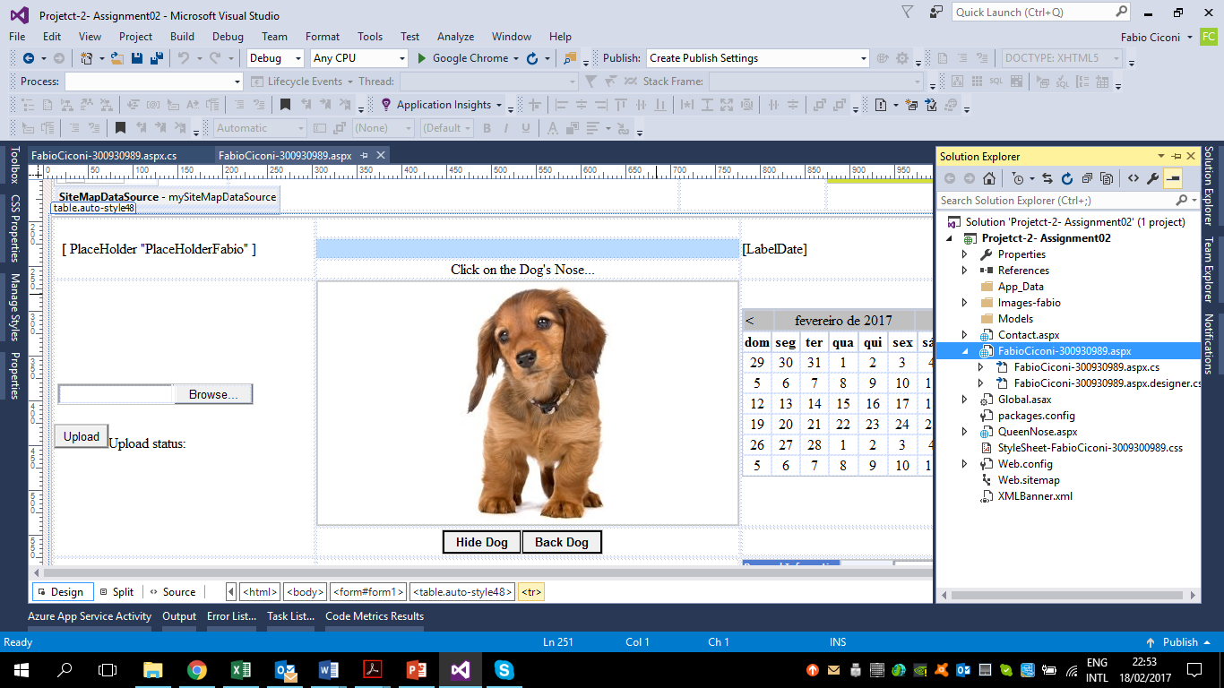

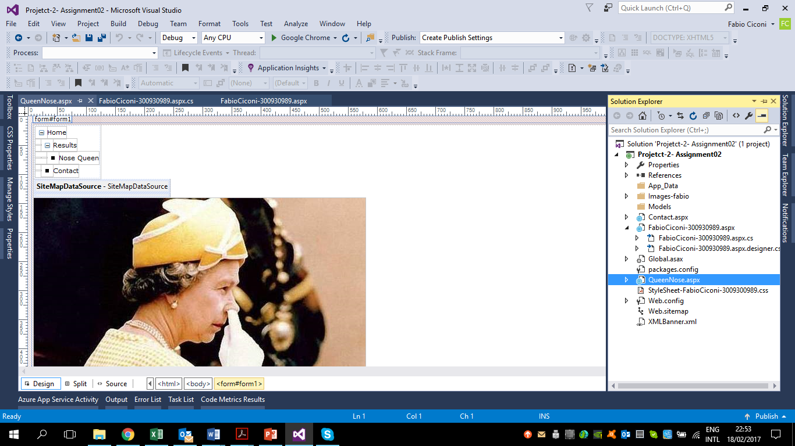

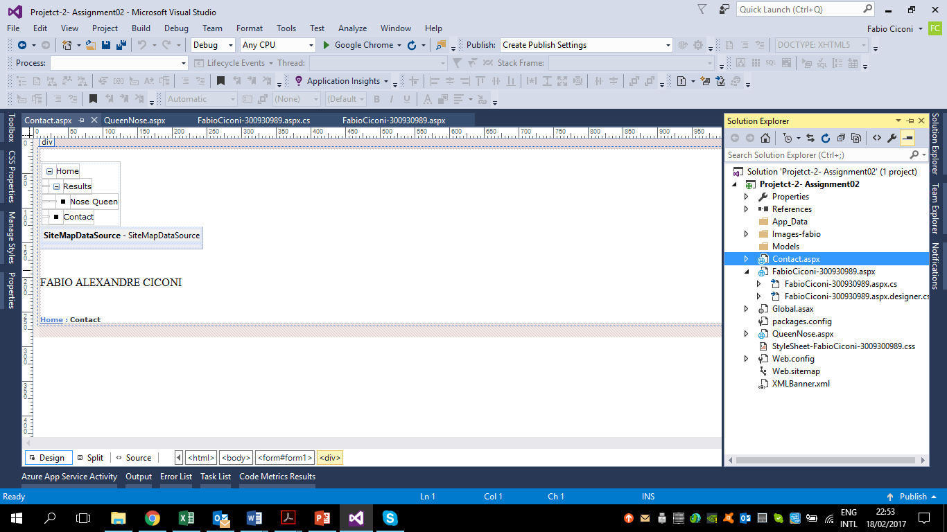

## CSS

head {

}

.auto-style47 {

width: 830px;

margin-left: 240px;

text-align: left;

}

.auto-style48 {

height: 600px;

}

.auto-style50 {

width: 459px;

height: 250px;

}

.auto-style51 {

width: 830px;

margin-left: 240px;

text-align: left;

height: 250px;

}

.auto-style52 {

height: 250px;

}

.auto-style54 {

width: 459px;

height: 32px;

text-align: center;

}

.auto-style55 {

width: 830px;

margin-left: 240px;

text-align: left;

height: 32px;

}

.auto-style56 {

height: 32px;

}

.auto-style57 {

width: 769px;

height: 23px;

}

.auto-style58 {

width: 459px;

height: 23px;

}

.auto-style59 {

width: 830px;

margin-left: 240px;

text-align: left;

height: 23px;

}

.auto-style60 {

height: 23px;

}

#LabelName{

margin-left:10px;

}

#CalendarFabio {

margin-top:-100px;

}

.auto-style26 {

width: 1040px;

height: 175px;

}

.auto-style27 {

height: 180px;

width: 1049px;

margin-bottom: 0px;

}

.auto-style28 {

width: 204px;

height: 110px;

}

.auto-style29 {

width: 518px;

margin-left: 80px;

height: 110px;

}

.auto-style34 {

width: 769px;

z-index: -1;

border-collapse: separate;

}

.auto-style37 {

height: 110px;

width: 170px;

}

.auto-style38 {

width: 830px;

margin-left: 240px;

text-align: center;

}

.auto-style39 {

width: 459px;

z-index: 1;

}

.auto-style42 {

width: 459px;

}

.auto-style43 {

width: 769px;

}

.auto-style44 {

width: 459px;

text-align: center;

}

.auto-style46 {

width: 830px;

z-index: 1;

}

#myMenu{

margin-top :-390px;

}

#mySiteMapPath2 {

margin-bottom :200px;

}

.auto-style21 {

position: absolute;

left: 650px;

top: 195px;

width: 810px;

height: 712px;

z-index: 1;

}

.auto-style23 {

width: 156px;

text-align: left;

z-index: -1;

}

.auto-style2 {

width: 156px;

}

.auto-style24 {

position: absolute;

top: 395px;

left: 645px;

z-index: 1;

}

.auto-style5 {

width: 1040px;

height: 91px;

}

.auto-style7 {

width: 802px;

}

.auto-style11 {

width: 156px;

height: 21px;

}

.auto-style12 {

width: 830px;

height: 21px;

}

.auto-style13 {

height: 21px;

}

.auto-style14 {

width: 172px;

}

.auto-style15 {

width: 802px;

margin-left: 80px;

}

.auto-style17 {

width: 830px;

}

.auto-style19 {

height: 92px;

width: 1049px;

margin-bottom: 0px;

}

.auto-style20 {

width: 129px;

height: 56px;

margin-left: 0px;

}

#MultiView1 {

}

body {

}

## XML

<?xml version="1.0" encoding="utf-8" ?>

<Advertisements>

<Ad>

<ImageUrl>\Images-fabio\CentennialCollege-banner.jpg</ImageUrl>

<NavigateUrl>http://www.centennialcollege.ca/</NavigateUrl>

<TargetUrl>_blank</TargetUrl>

<AlternateText>blank</AlternateText>

<Keyword>blank</Keyword>

<Impressions>1</Impressions>

</Ad>

<Ad>

<ImageUrl>\Images-fabio\Banner-Fabio.jpg</ImageUrl>

<NavigateUrl>http://www.fabiociconi.wixsite.com/meusite</NavigateUrl>

<TargetUrl>_blank</TargetUrl>

<AlternateText>blank</AlternateText>

<Keyword>blank</Keyword>

<Impressions>2</Impressions>

</Ad>

<Ad>

<ImageUrl>\Images-fabio\banner-teacher.png</ImageUrl>

<NavigateUrl>http://smrdibaj.wixsite.com/smrezadibaj/teaching</NavigateUrl>

<TargetUrl>_blank</TargetUrl>

<AlternateText>blank</AlternateText>

<Keyword>blank</Keyword>

<Impressions>3</Impressions>

</Ad>

</Advertisements>

<?xml version="1.0" encoding="utf-8" ?>

<siteMap xmlns="http://schemas.microsoft.com/AspNet/SiteMap-File-1.0" >

<siteMapNode url="~/FabioCiconi-300930989.aspx" title="Home" description="Home Page">

<siteMapNode url="" title="Results" description="Results of Clicks" >

<siteMapNode url="~/QueenNose.aspx" title="Nose Queen" description="Queen" />

</siteMapNode>

<siteMapNode url="Contact.aspx" title="Contact" description="ContacUs Page" />

</siteMapNode>

</siteMap>